BCIS-5610 DATA WAREHOUSING
BY
PROF KASHIF SAEED

Assignment 3- Development of QlikView Application on Dimensional Model

BY
SAI SNEHA AARIGA

SQL SCRIPT:
I've divided the script into six separate Tabs.
- Main Tab:
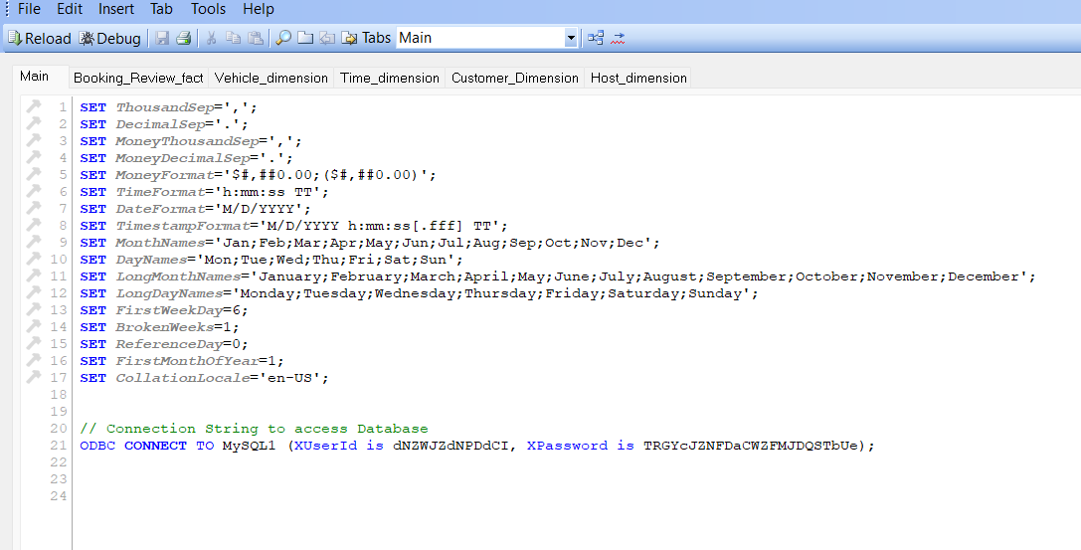
- Booking_Review_fact
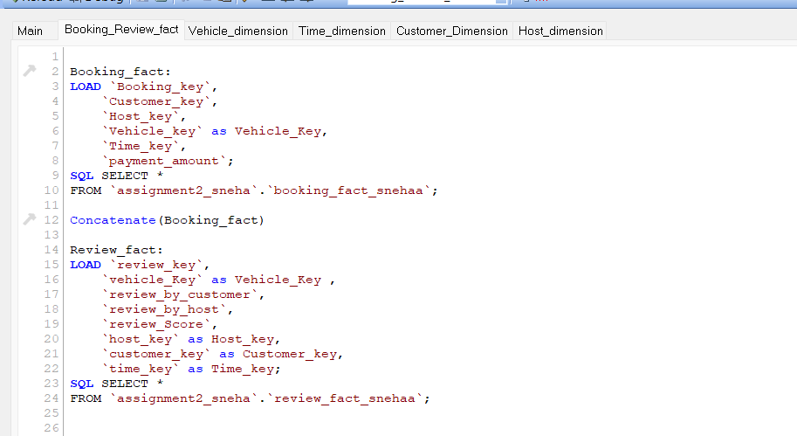

- Vehicle_dimension:
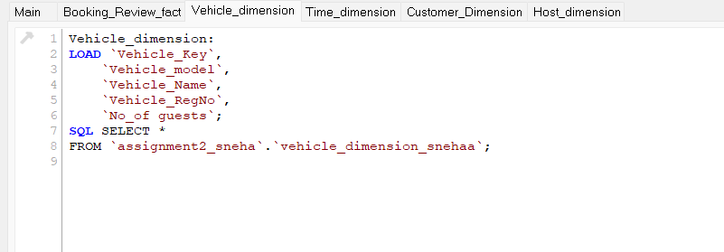
- Time_dimension:
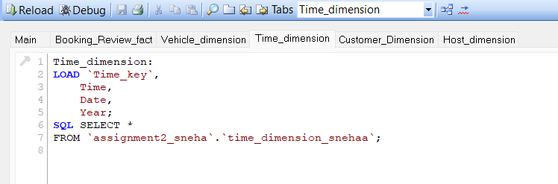
- Customer_dimension:
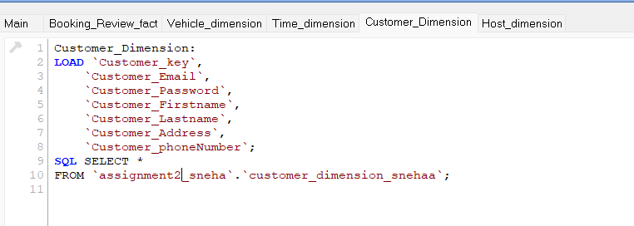

- Host_dimension:
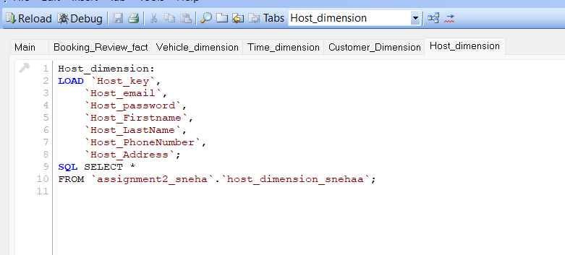

Dimensional Model in QlikView after Synthetic Key Removal:

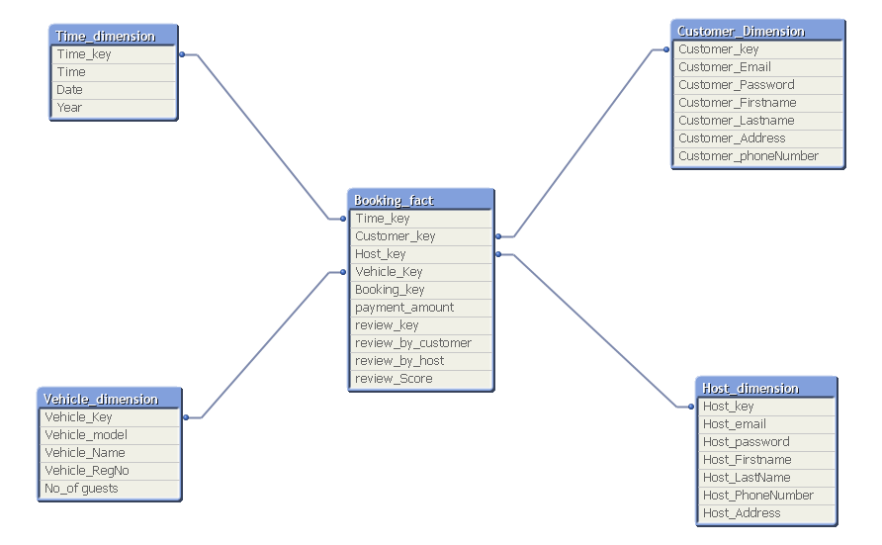

Front End Development:
I've developed three separate sheets in the front end.
- Main:
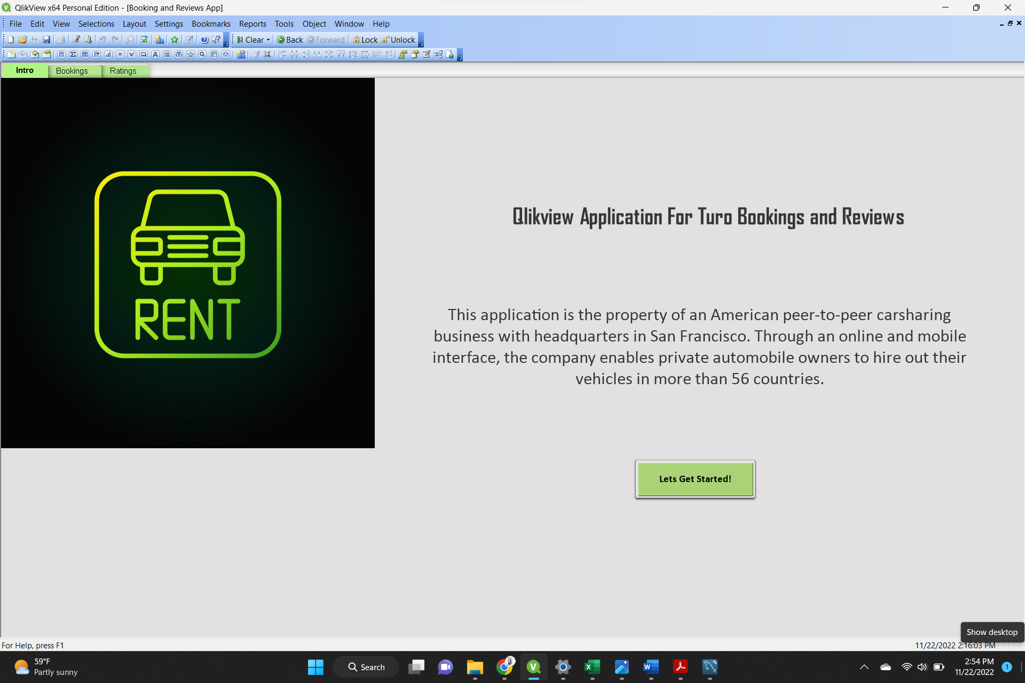
- Added textbox with the description for application.
- Added a background image and color for this dashboard.
- Added a button to navigate to the next sheet.

- Bookings dashboard:
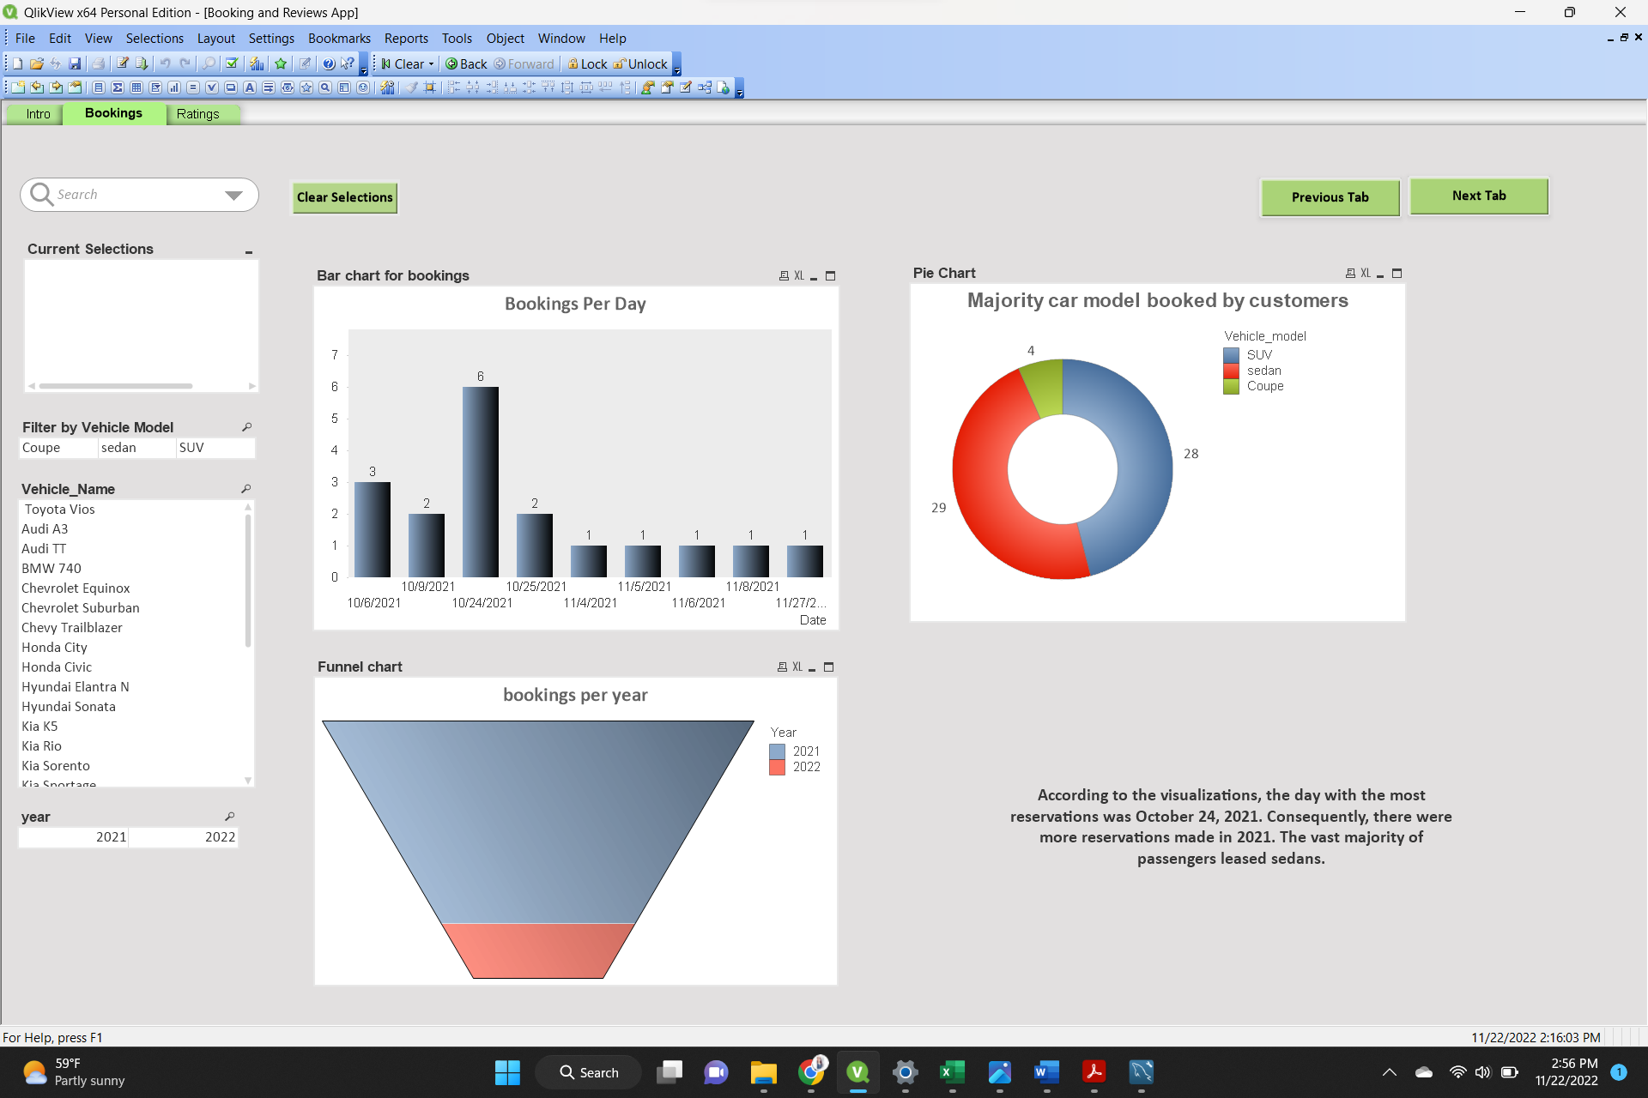

- Added a search object, current selections to the dashboard.
- Added a button for clear sections to clear all the selected fields
- Added a previous tab and next tab buttons to navigate to previous and next pages.
- Added list boxes to filter by year, vehicle name and vehicle model.
- Added a funnel chart to represent the bookings per year
- Added Pie chart to differentiate the majority car models booked by customers.
- Added a bar chart to show the number of cars reserved for each date and selected value to data points for labelling
- Added a text box for the summary of charts

- Ratings:
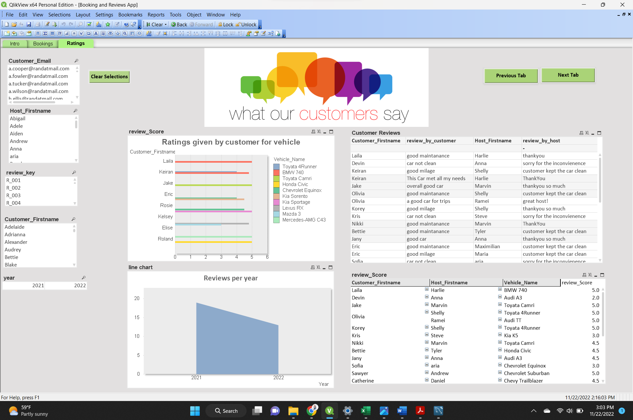

- Added a background image and color for this dashboard.
- Added a button for clear sections to clear all the selected fields
- Added a previous tab and next tab buttons to navigate to previous and next pages.
- Added list boxes to filter by year, customer email, host first name, review key and customer first name.
- A pivot table has been included to show which customers have rated which host and his vehicle.
- For viewing the feedback from guests and hosts, a straight table has been built.
- Added a bar chart to show the ratings given by customers to their booked car and selected value to data points for labelling.
- Added a line chart to represent reviews per year

